REPORT

|  |  |
| --- | --- |
| Date | 11 November 2022 |
| Team ID | PNT2022TMID31397 |
| Project name | Retail Store Stock Inventory Analytics |
| Team members | Mohammed Muzakeer M  Vishal D  Abhirami B  Janani R |

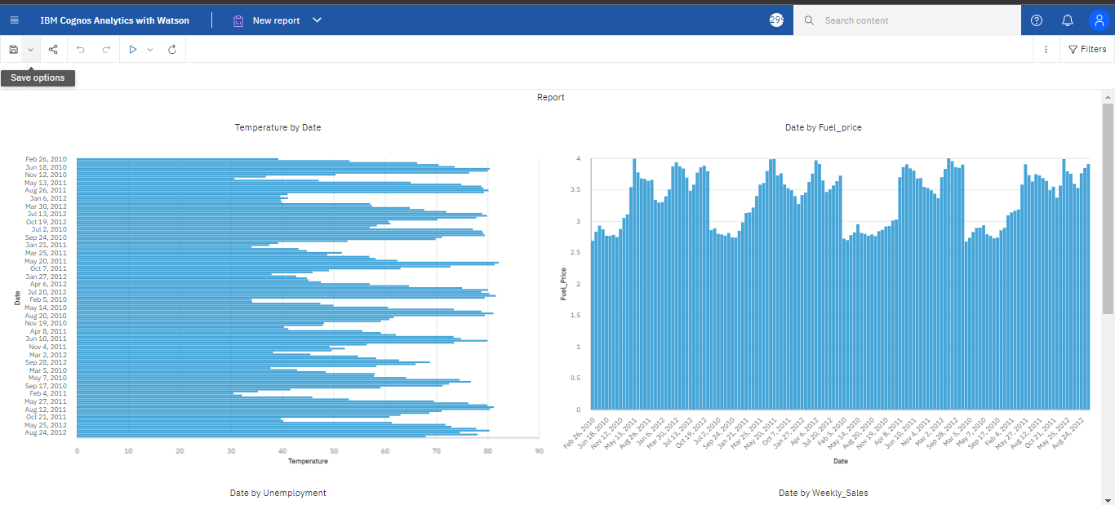

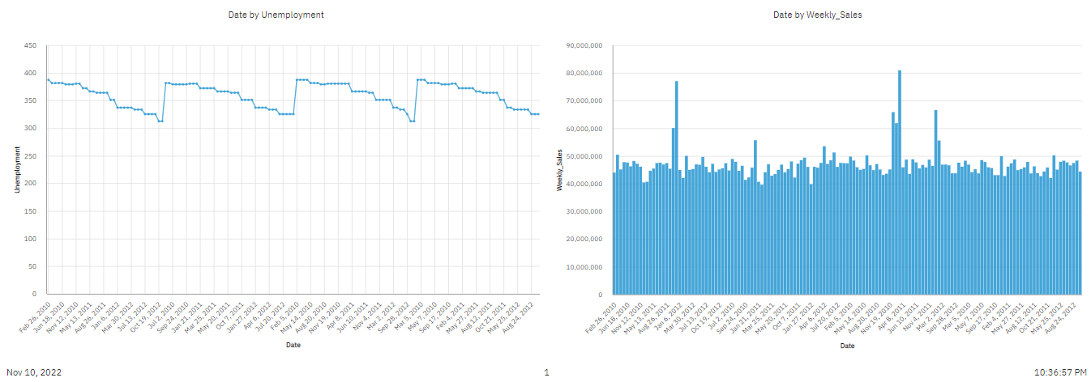

Reference link:

<https://us3.ca.analytics.ibm.com/bi/?pathRef=.my_folders%2FReport%2BModule%2Fsprint%2B4%2Bgenerated%2Bfile&action=edit>